**Tableau Project Work**

**CAB ANANLYSIS**

STORY

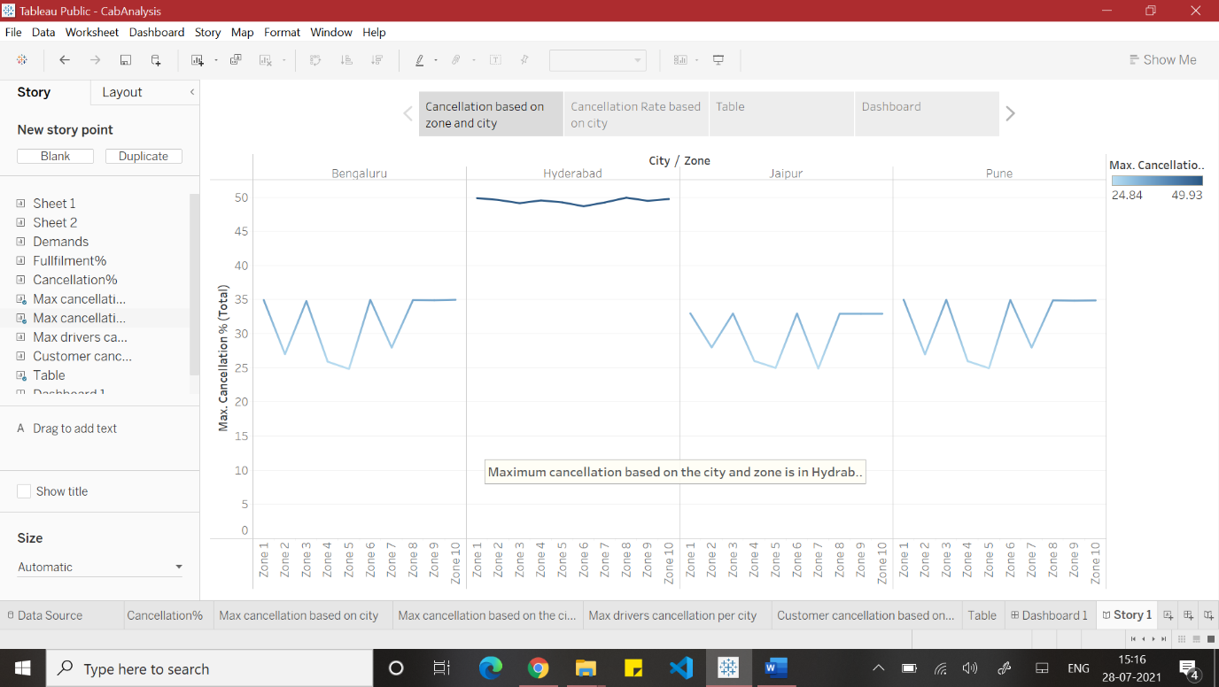

Based on the analysis it was found that the maximum number of calculations were in Hyderabad city in Zone 8 area of about 49.93.

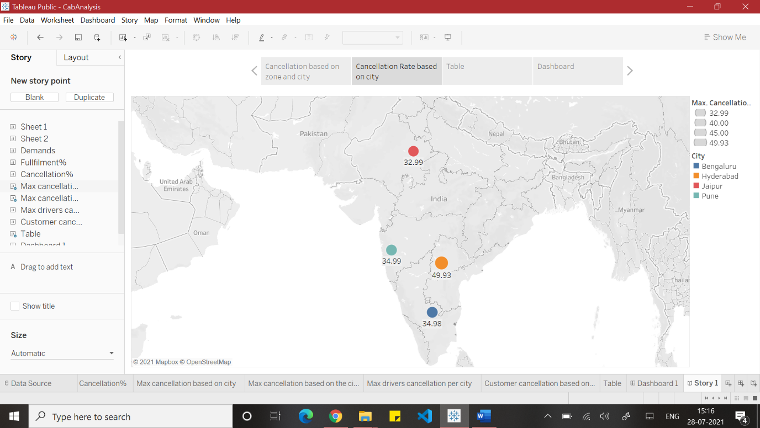

The cancellation rate based on the city which was plotted using a geographical map where cancellation rate in Hyderabad is 49.93, Bengaluru is 34.98, Pune is 34.99 and in

Jaipur is 32.99 .

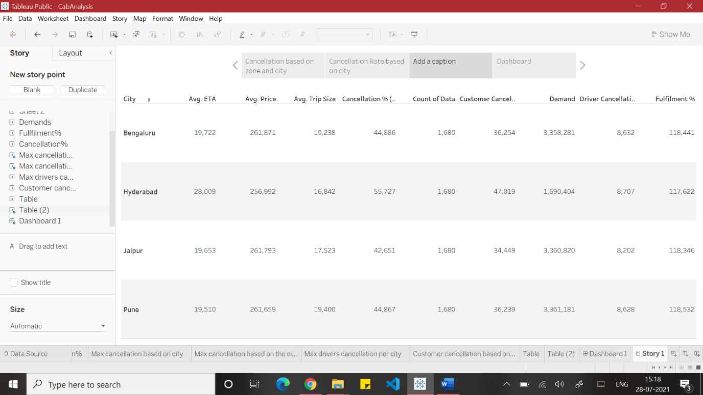

As per the analysis in the above table it was found out that the avg. price was lower in Hyderabad compared to other cities. Along with avg. ETA, customer cancellation rate, drivers cancellation rate was also found to be higher in Hyderabad city.

**DASHBOARD**

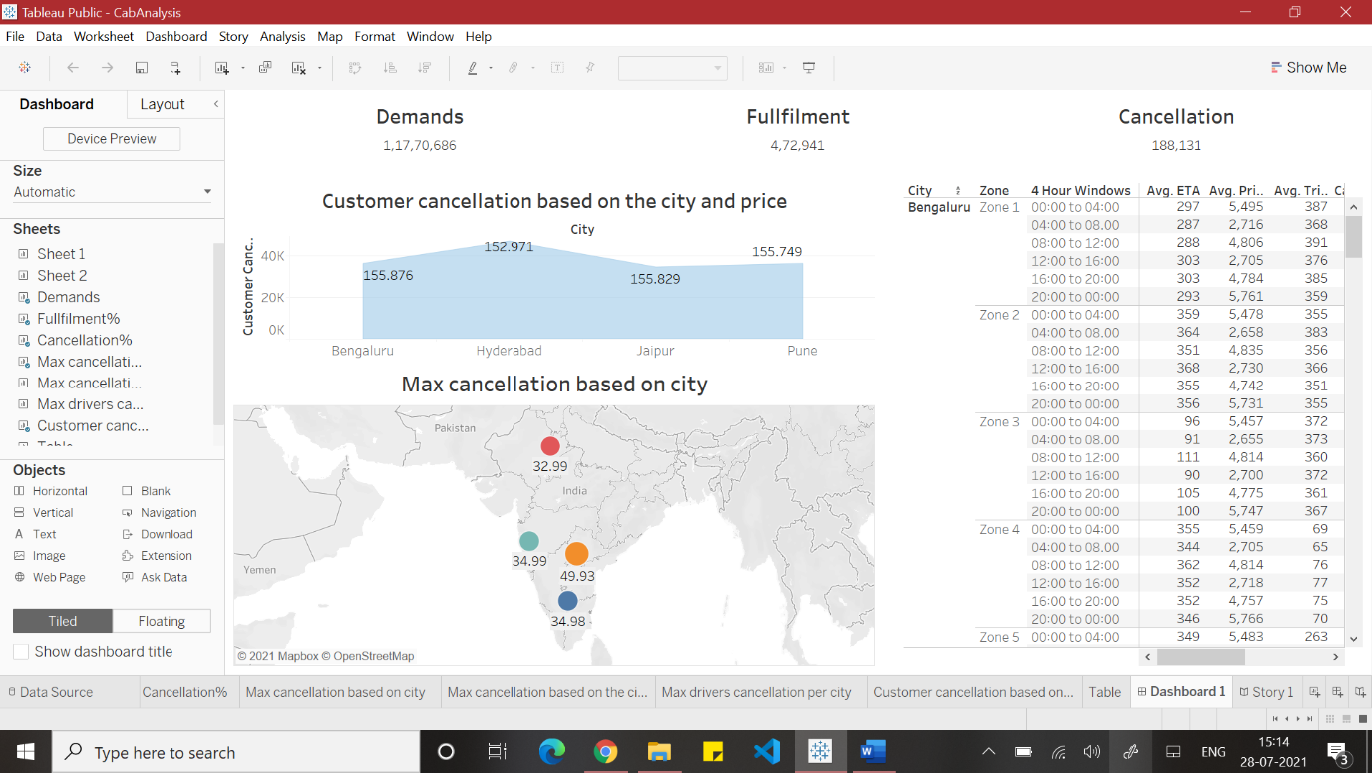

A dashboard was created based on the given cab analysis dataset where total demands, total fulfilment and total cancellation has been shown. Along with customer cancellation based on the city and price was plotted using area chart. Max. cancellation based on the city was plotted using geographical map and Hyderabad city was found to be the highest. And a table was created for the zone, 4 hours window and measured values to show the analysis of the cities.